# **Domain knowledge**

**Chiller plant structure**

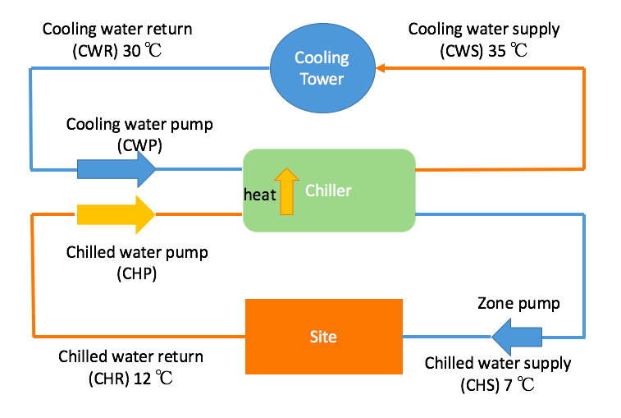  
Copied:  
[I personally find the notation confusing, we can sit down and discuss if we want another notation. For now, this is Rubio's notation and industry in general. Return refers to return back to chiller, supply refers to output of chiller, or chiller is supplying.

At site, chilled water supply brings the heat away from machines, so that machines can cool down. As a result, chilled water returns to chiller at a higher temperature (12°C).

Inside the chiller, heat is brought away by refrigerant and dumped to cooling water return. (optional) See explanation future down how refrigerant is able to do that.

As a result of receiving heat inside chiller, cooling water supply has higher temperature than cooling water return.

How cooling tower is able to cool down cooling water supply is by exposing it to ambient air and bringing the heat away by evaporation. This is why ambient air temperature and relative humidity is a parameter.

So ultimately, heat generated from site is brought away by chilled water, passed down to chilled water inside chiller, which is then brought away by air in cooling tower.]  
  
-Aims:   
  
1) Optimise the 3 pumps  
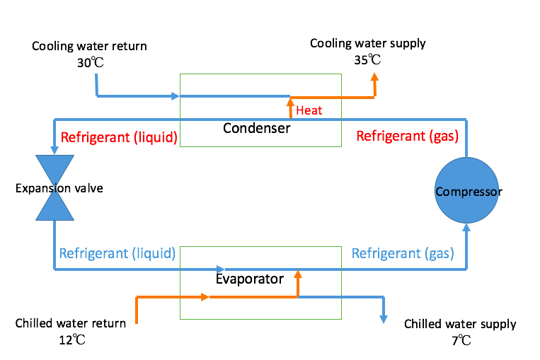  
  
**Note**

In c1_final, most likely temp1 is chilled water supply, temp2 is chilled water return; temp4 is cooling water return, temp3 is cooling water supply.

## **What is evaporator and condensor flow rate?**

To understand that, let us take a look at what is inside a chiller.

Evaporator is where refrigerant in liquid form evaporates, bringing the heat away from chilled water return. As a result, chilled water supply has a lower tempearture, ready to cool the machine, and refrigerant becomes gas. Evaporator flow rate refers to the flow rate of the chilled water, not refrigerant.

Condensor is where refrigerant gas condenses into liquid, releasing heat in the process. The heat is dumped to cooling water return. As a result, cooling water supply has a higher temperature, and refrigerant liquifies. Condenser flow rate refers to the flow rate of cooling water.

## **Function and parameters**

### **COP**

Coefficient of performance COP is a function of 4 temperatures (CWR,CWS,CHR,CHS or just T1,T2,T3,T4), 2 flow rates (condenser and evaporator flow rate, it just means chilled water and cooling water flow rate respectively) and cooling capacity Q (this will be explained later).

COP = f (T1,T2,T3,T4,dV/dt1,dV/dt2,Q) (dV/dt means flow rate, or volumn over time)

Cooling capacity Q is the measure of a cooling system's ability to remove heat.

Cooling capacity = mass rate x specific heat capacity x temperature change = density x flow rate x specific heat capacity x temperature change

Q = ρ *dV/dt* cp * ΔT (ΔT = chilled water return - chilled water supply, or temp2 - temp1)

Note: water density changes with temperature, so it is not a constant. cp = 4.19kJ/kg

### **Power**

Coefficient of performance = cooling capacity / power consumed by chiller (note: chiller only)

COP = Q / W chiller

W total = W cooling_tower + W cooling_water_pump + W chiller + W chilled_water_pump (ignore W zone_pump?)

W cooling tower = f(cooling water flow rate, ambient tempertaure, relative humidity) (to be examined furture)

W cooling_water_pump = f(cooling water flow rate, or condenser flow rate)

W chiller = f (T1,T2,T3,T4,dV/dt1,dV/dt2,Q) since W chiller = Q / COP

W chilled_water_pump = f(chilled water flow rate, or evaporator flow rate)

### **Note**

COP the higher the better, total power the lower the better.

Majority of my formula comes from this link, please read the original document.

<https://ac.els-cdn.com/S1877705817346088/1-s2.0-S1877705817346088-main.pdf?_tid=25438eae-e4c8-11e7-9ca3-00000aab0f01&acdnat=1513693573_346997bd0ac086891476fa82bb274064>

Please point out potential mistakes! :)